# **GENERAL INFO**

* *Course: 313CCS-5*
* *Assignment no: 2*
* *Marks: 4 marks*
* *Due Date on 21-May-2023*
* *Submit on Blackboard 1 pdf file.*
* *For extra credit, the game should be uncommon, and algorithms should be well written*
* *For issues, email me immediately.*
* ***Important Note!*** 
  + *You are not allowed to use any external sources without citation, including any AI-assisted tools.*
  + *Your answer must show and reflect your effort and views.*

Find or **invent a board game notion that involves challenges and more than one player.** Then, answer the following questions.

1. **What is the name of your game (if it does not, make one)?**

**Little nightmares**

1. **Sketch or draw the game idea and the board if available.**

The game is described by its name, as the game describes the childhood fears experienced by all children, from fears of tall people, of shame, of dolls, or even of things considered normal to some, but to others considered very scary. And it is terrifying for some, so the basis of the game is the little child number six who is trying to escape from the dormitory, but all the things and rooms surrounding him are his fears that are in his heart, and you have to help the child until he finds the vandal without being arrested by one of the fears inside the dormitory, such as (the cook or the lady or the dolls)

1. **Write about how to play the game?**

The way to play is the simplest and easiest, but it requires intelligence and skill at the same time. The game is of the 2D type, which forces the game to move forward and backward only.

The player has to walk forward, solve puzzles, jump and hide from people who might arrest him

1. **What are the Game Rules, including winning and losing events?**

The player must solve the puzzles in each stage in order to be able to move to the next stage.

The player must not be detected escaping from any of the other characters present.

The player must not jump from high cliffs or tall buildings.

The player has to discover how to pass the challenge to move on.

If the player can solve the puzzles, he is considered to have partially won, and if he can escape, he jumps and wins the game.

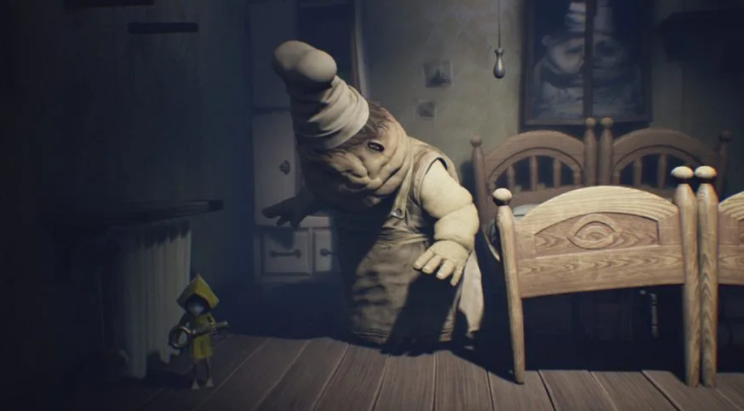If the player jumps from a high place or is caught by one of the characters, he will lose and return from the loss area to play again

**Write an algorithm for loading and saving the player’s data. Start, for example, start from “when the user clicks ctrl+s ”. (Note! The data and their types must be clearly specified)**

* + If the player want to save the game:
  + Press on ctrl+s
  + Write in the filed number of save (int)
  + Name of player (string)
  + Level(int)
  + Press save,close
  + If the player want to load:
  + Press on ctrl+l
  + Choose the file you want
  + Return the number of save(int)
  + Press load,press close, done

**Explain if there is an economic system, spawning process, or use of Randomness in the game?**

The game inside it does not contain any economic system or buying and selling

But if we can consider the price of the game that is paid to obtain the game and buy it with the player forever as an economic system, then here it is considered that the revenues of the game designers are only from buying the game itself.

As for the situation inside the game, the game is very simple and there is no economic system or buying and selling in any way.